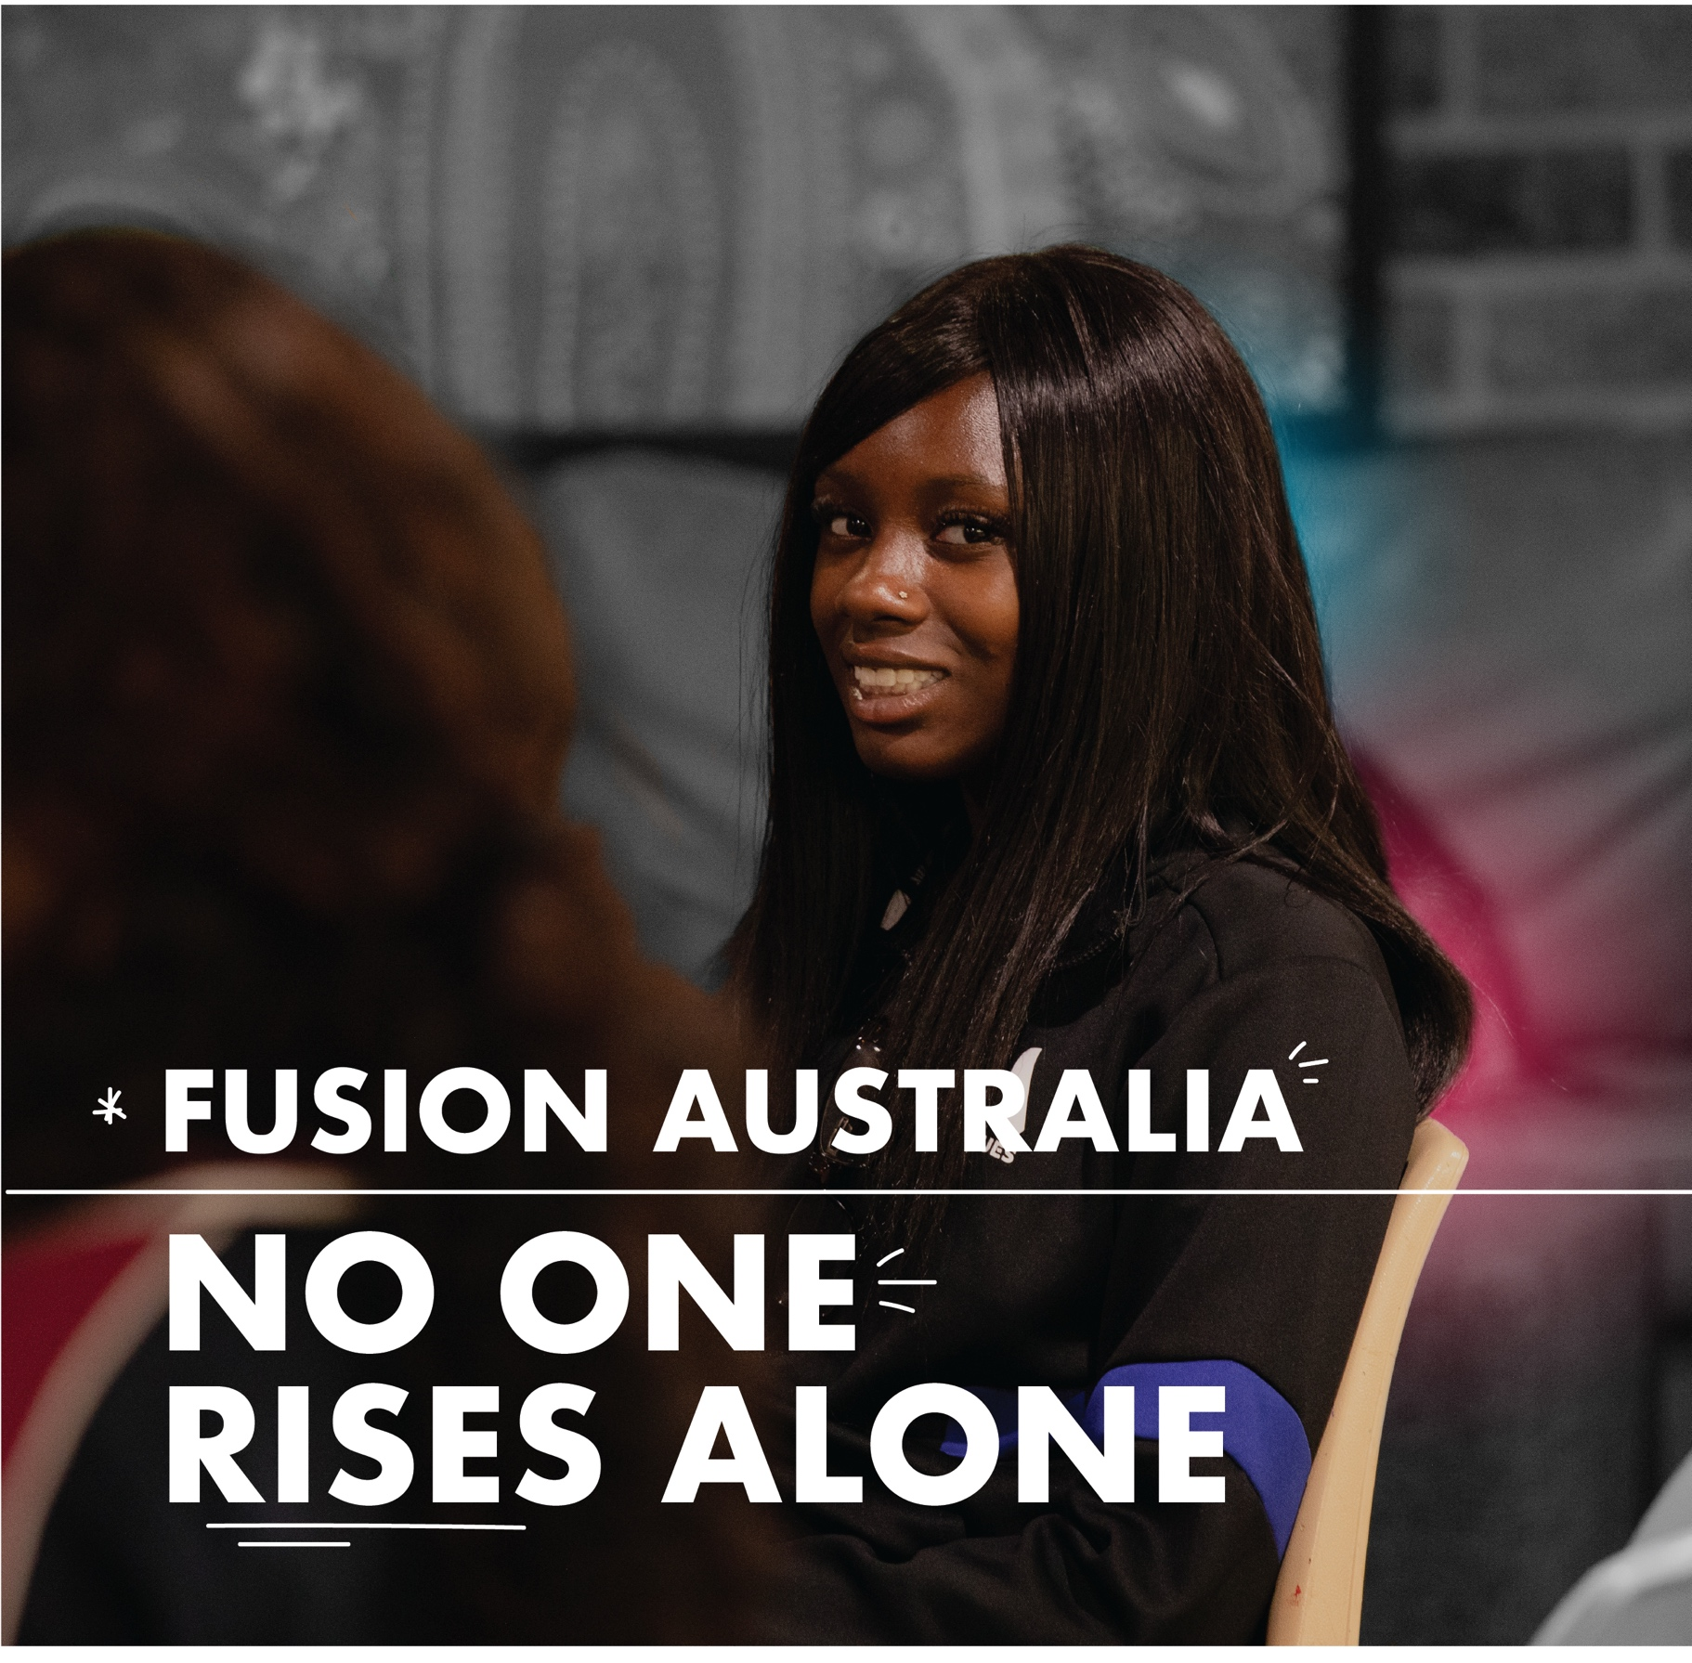
FUSION AUSTRALIA
ANNUAL REPORT


2025

ACKNOWLEDGMENT OF COUNTRY
Fusion Australia acknowledges the Traditional Owners of Country throughout Australia.

As we work across the country, we pay our respects to the Elders of these lands, past and present.

CONTENTS

Who We Are 3

Our Vision, Mission and Values 3

Organisational Report 4

What We Do 6

Our Impact in 2025 7

Program Highlights 8

Our Board & CEO 12

Financial Overview 15

Acknowledgements 16

Contact Us 17

WHO WE ARE
Fusion Australia is a Christian, for-purpose youth-services organisation. We are a registered charitable not-for-profit and a verified provider of National Community Housing. We receive a variety of local, state and federal government funding and social enterprise income to deliver a range of early intervention and focused youth services.

Fusion Australia recognises that many young people in Australia face barriers at crucial times in their lives - unstable housing, childhood trauma, mental distress, isolation, and poverty. That’s why Fusion Australia works to build strong foundations for young lives: a safe place to stay, a trusted mentor, and a community that believes in them. Our services are professionally delivered, outcomes-focused and trauma-informed to build young people up so they can find their way, develop with confidence, and step into their future. Because no one rises alone.

OUR VISION
Young people in Australia have purpose and connection, in a community that cares for them.

OUR MISSION
Mentoring and equipping young people who are vulnerable to build a strong foundation for their future.

OUR VALUES
Justice
Compassion
Mercy
Respect

ORGANISATIONAL REPORT

From our CEO and Board Chair

Young people in Australia are navigating a world of change which offers expanding choices and connections, while also presenting new and persistent challenges. Opportunities to learn, work and engage are increasing, but so too are pressures related to mental health, cost of living, housing and social disconnection. This mixed reality shapes the context in which our work takes place.

In supporting young people, our teams across the country continue to provide practical support. For example, this year Fusion Australia supported 635 young people through mentoring programs and provided 22,036 nights of safe accommodation through supported housing initiatives.

While this work remains constant, the environment around it is changing significantly. The youth, community and housing sectors are facing increasing demand, rising costs and workforce challenges. Funding is increasingly directed toward larger, integrated service models. Expectations of governance, data, and service quality continue to rise. Organisations that are unable to clearly demonstrate their impact and operate sustainably will find it increasingly difficult to compete.

These conditions have required deliberate changes to how we manage risk, prioritise resources, and deliver services. We must become more focused, more disciplined, and more accountable in how we deliver our work.

In response, we have launched the Fusion Australia Strategic Framework 2025 – 2027, setting a clear direction to move toward a sustainable and targeted service portfolio delivering measurable impact for young people.

Our focus is to strengthen what we do well, improve the consistency and quality of our programs, and make clear decisions about where we are best placed to operate.

This strategy is already underway. During the year we have invested in both our operating capability and program portfolio alignment to support consistent, safe and compliant service delivery. This investment has included further improving financial capabilities, tightening governance practices, and strengthening corporate services. A number of programs and organisational functions were reviewed, leading to decisions to strengthen some areas of work and to cease or transition others that are no longer aligned with our strategy or sustainable over time.

One such decision was to handover the Fusion Mental Health Units in Geraldton to a new provider. This deliberate choice was not a reflection on the value of the program, but a recognition that another provider is better positioned to deliver specialist mental health services at the scale and standard required to better serve clients. Handover is due to take place in June 2026.

We thank our partners who work alongside us and share in the commitment to supporting young people in their communities. Your ongoing support and collaboration make this work possible. This includes funders, foundations and service delivery partners.

We thank our staff and volunteers who continue to serve young people with dedication and care, often in demanding circumstances. This includes both our frontline teams, who walk directly alongside young people, and our support teams, whose work enables safe, consistent and effective service delivery across the organisation.

We acknowledge and thank Rohan Prowse for his service as a Director, concluding his term in early 2026. His contribution to the organisation has been valued and appreciated.

Finally, we thank the young people who entrust us to be part of their lives.

PATRICK WITCOMBE
Chief Executive Officer

and

PAUL RYAN
Board Chair

HOW WE SUPPORT

YOUNG PEOPLE

At Fusion Australia, we support young people to find purpose and connection in communities that care. We engage early, walk alongside people through challenge, and invest in their strengths so they can build strong foundations for the future.

Our services are shaped around key areas of need, working holistically with individuals, families and communities to create lasting impact.

YOUTH WORK IN SCHOOLS
Delivering evidence-informed, school-based programs that build resilience, wellbeing, and positive connections, helping young people feel safe, engaged, and better equipped to navigate life and learning, including seminars, structured group programs, and informal recreational activities.

YOUTH WORK IN COMMUNITY
Creating inclusive community-based activities and safe spaces where young people develop belonging, relationships, and life skills that strengthen resilience and connection, including recreational programs, outreach, and adventure-based learning.

TARGETED SUPPORT OF YOUNG PEOPLE
Providing tailored, intensive support - including casework, counselling, early intervention, living skills development, and referral and advocacy - for young people facing higher risk, enabling stability, independence, and improved life outcomes.

HOUSING AND SUPPORT
Providing crisis to medium-term housing and outreach support alongside wraparound, trauma-informed care, enabling young people to build life skills, strengthen wellbeing, and transition toward long-term independence and housing stability

ENTERPRISES AND MATERIAL RELIEF

Generating sustainable income and delivering essential food and material support that reduces hardship, improves immediate wellbeing, and strengthens community resilience, while reinvesting resources to increase impact for young people.

COMMUNITY PROGRAMS
Delivering inclusive community programs and supports for families and broader age groups - such as parenting programs, family connection activities, and community-wide events - that strengthen relationships, build family capacity, and foster supportive environments where young people are more connected, resilient, and able to thrive.

OUR IMPACT IN 2025

In 2025 we supported 11,817 people in Australia through:
549 youth school programs
862 youth community programs
1,890 one-on-one youth mentoring or casework sessions
1,191 general community programs
1,167 Home Modifications or Maintenance

Including:
860 people supported towards stable accommodation and living
across 22,036 bed nights
1,300 supported with community meals
21,386 instances of food relief

Thanks to the work of:
170 Employees and 388 Volunteers

OUR 2025 HIGHLIGHTS
Stories from our programs throughout the year.
Names have been changed to protect privacy.

BUILDING A STRONG FOUNDATION THROUGH SCHOOLS BASED YOUTH WORK

Strengthening identity, confidence and wellbeing to help young people feel connected and capable of a positive future.
Grace, a young Australian student of Samoan heritage entered the Make Your Mark program feeling uncertain about her cultural identity and experiencing instability across home and school environments. Moving between households and peer groups left her feeling disconnected and unsure of where she belonged.
Throughout the term, the program provided a consistent and supportive space for reflection. Grace engaged strongly with the program’s Te Whare Tapa Whā model, which supported her to understand her wellbeing holistically and begin rebuilding a sense of identity and balance. This framework played a key role in strengthening her confidence and establishing a foundation for her future.
As the program progressed, youth workers observed clear growth in her body language, participation, and overall self-assurance. She began to express pride in her cultural background and contributed more openly within the group.
By the end of the program, Grace demonstrated significant confidence by performing a traditional Samoan siva (dance) for the first time and volunteering to write and present a speech at the program’s showcase event. These milestones reflected a renewed belief in her voice and her potential.
In her feedback, she shared that she now feels more connected, heard, and confident in her identity.
Most importantly, she expressed that the program helped her feel capable of a positive future, with the confidence and foundation needed to pursue her goals.

BUILDING A STRONG FOUNDATION THROUGH YOUTH LEADERSHIP CAMP

Fostering confidence, connection and belonging through shared experiences and peer-supported growth.
This year’s youth camp brought together a diverse group of young people, including both new participants and those returning. While new group dynamics can present challenges, the program’s strong, values-based culture provided a consistent foundation from the outset.
Throughout the camp, young people were encouraged to affirm one another, work collaboratively, and engage in meaningful discussion. A range of activities challenged participants both individually and as a group, creating opportunities to build confidence, resilience, and trust.
Participants were given space to reflect, listen, and contribute, strengthening their sense of connection and belonging within the group. One young person shared that they “really enjoyed getting to meet new people and stepping outside my usual circle.”
These shared experiences foster a supportive environment where young people feel valued and included. In turn, this strengthens their confidence and equips them with the interpersonal skills and self-belief needed to navigate challenges beyond the camp setting.

BUILDING A STRONG FOUNDATION THROUGH SAFE HOUSING AND SUPPORT

and confidence needed for independent living.
Taylor entered our refuge program following a period of housing instability, limited family support, and increasing disengagement from education. On arrival, they identified challenges with routine, anxiety and confidence, and felt uncertain about their ability to live independently. Their immediate needs centred on safety, stability, and rebuilding confidence.
Over 12 weeks, through consistent mentoring, structured case management, and a safe living environment, Taylore began to establish daily routines and develop essential independent living skills. This included budgeting and managing expenses, maintaining their living space, navigating shared living arrangements, attending appointments, and re-engaging with education.
Over time, tasks that once felt overwhelming became achievable and, increasingly, enjoyable.
Staff observed a significant shift in confidence and independence. Taylor achieved their case management goals, returned to full-time education, and demonstrated increased responsibility in their day-to-day life. They also felt confident enough to share a creative project they had developed during the program.
Importantly, they developed stronger coping strategies and a more positive outlook for the future.
Upon exiting the program, Taylor reflected that stable accommodation, consistent support, and the living skills program provided a strong foundation for long-term independence, stability, and wellbeing.

BUILDING A STRONG FOUNDATION THROUGH PARTNERSHIP

Demonstrating how sustained partnership delivers measurable improvements in wellbeing, resilience and long-term outcomes for young people.
Bobby, a participant in the program, described it simply: “I really think it (Fusion Australia) saved my life sometimes.”
In 2025, Fusion’s Youth Wellbeing Program in Perth - delivered in partnership with the Stan Perron Charitable Foundation - supported a group of young people experiencing homelessness, trauma, and significant mental health challenges. At entry, most participants presented with clinical levels of anxiety, depression, and high stress, highlighting the complexity of need.
Through consistent engagement across the year, young people participated in a range of structured, therapeutic and community-based activities, including equine therapy, creative programs, and outdoor experiences. These were designed to support emotional regulation, build trust, and strengthen connection and belonging.
By the end of the program, outcomes demonstrated significant improvement across all key measures. The number of participants experiencing clinical levels of depression and anxiety reduced substantially, and every young person recorded an improvement in overall wellbeing. All participants also reported feeling safe and supported throughout the program.
Beyond the data, young people developed stronger coping strategies, increased self-awareness, and began to build trusting relationships with adults - often for the first time. Importantly, many also began to express hope for their future and a sense of possibility.
These outcomes were made possible through sustained philanthropic partnership. Support from the Stan Perron Charitable Foundation enabled a consistent, wraparound model of care, bringing together multiple services to respond to complex needs in a coordinated way.
Looking ahead, the program is well-positioned to deepen its impact. Early improvements in wellbeing are expected to contribute to stronger long-term outcomes, while ongoing refinement of the model and continued partnership will support expansion to reach more young people.
This partnership demonstrates the power of combining evidence-based practice with long-term investment - creating not only immediate change, but a foundation for lasting impact.

OUR BOARD OF DIRECTORS
The following outlines the qualifications, tenure, and committee responsibilities of Fusion Australia’s Board Directors, demonstrating the breadth of governance, financial, and sector expertise supporting the organisation.

PAUL RYAN
Board Chair
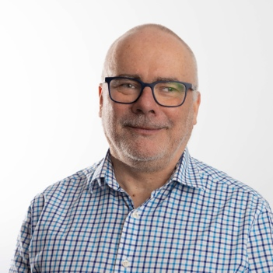 | Bachelor of Theology; Bachelor of Science (Honours – Psychology); Graduate Diploma in Psychological Studies; Graduate of the Australian Institute of Company Directors.  Joined the Fusion Board of Directors in September 2022. Board Chair and Member of the Care and Corporate Governance Committee.

THOMAS GRIFFITHS
Deputy Board Chair; Finance and Audit Committee Chair
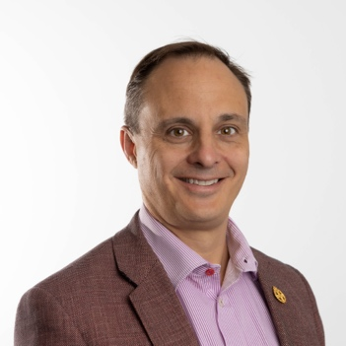 | Fellow of Chartered Accountants Australia and New Zealand; Master of Applied Finance; Graduate of the Australian Institute of Company Directors.  Joined the Fusion Board in 2023, is the Deputy Chair and Chair of the Finance and Audit Committee.

SARAH FRASER
Care & Corporate Governance Committee Chair
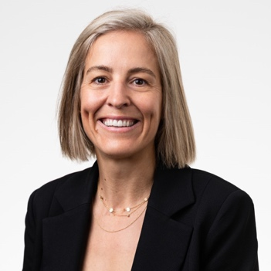 | PhD (Public Health); Master of Nursing (Child Health and Development); Bachelor of Nursing.  Joined the Fusion Board in July 2024 and Chair of the Care and Corporate Governance Committee.

LASHITHA DEVADASON
 | Member of Chartered Accountants Australia and New Zealand; Bachelor of Commerce (Honours).  Joined the Fusion Board in July 2024 and Member of the Finance and Audit Committee.

BEVERLEY RANKIN
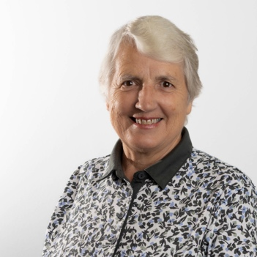 | Bachelor of Science (Forestry); Graduate Diploma of Theology; Diploma of Youth and Community Work; Certificate IV in Training and Assessment; ICDA Certified Community Director.  Joined the Fusion Board in 2023.

ANNELISE SCHRODER
 | Bachelor of Laws (Honours); Bachelor of Social Science.  Joined the Fusion Board in 2023 and Member of the Finance and Audit Committee.

DOROTHY KNOX
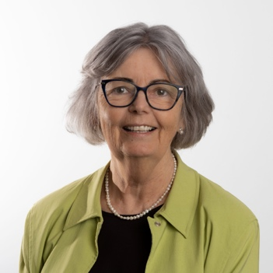 | Bachelor of Arts (Sociology); Diploma of Education; Certificate IV in Youth and Community Work; Certificate IV in Training and Assessment; ICDA Certified Community Director.  Joined the Fusion Board in 2021 and Member of the Care and Corporate Governance Committee.

STEPHEN HAMILTON
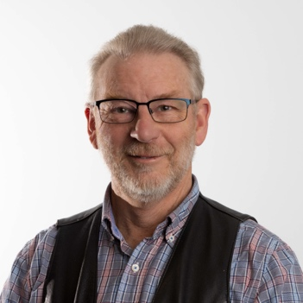 | Diploma of Youth and Community Work; Graduate of the Australian Institute of Company Directors; Electrical Trades Certificate.  Member of the Fusion Board. Member of the Care and Corporate Governance Committee.

ROHAN PROWSE
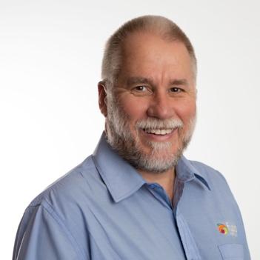 | Bachelor of Economics (First Class Honours); Associate of the Institute of Actuaries of Australia; Diploma of Youth and Community Work.  Served on the Fusion Board during 2025 and Member of the Finance and Audit Committee.

PATRICK WITCOMBE
CEO + Company Secretary
 | Bachelor of Laws; Bachelor of International Studies; Master of Business Administration.  Appointed CEO in September 2024. Member of the Finance and Audit Committee and the Care and Corporate Governance Committee.

For more about our Governance and Management team please visit our website at fusion.org.au/about-us/management

FINANCIAL OVERVIEW
For our full Financial Report please access it here or via our website at fusion.org.au/annual-report.

WHERE THE MONEY CAME FROM
Government Funding | 63.7%
Fundraising Income | 6.2%
Self-Generated Income | 30.5%
Passive Income | 0.5%

Deduct: subsidiary income -1.0%

WHERE THE MONEY WAS SPENT
Training and Education | 3.3%
Youth and Other Housing and Accommodation Services | 35.3%
Frail and Aged Assistance | 16.2%
Youth Work Activities | 24.1%
Youth and Community Activities | 1.4%
Fusion Australia Op Shops | 7.5%
Other Social Enterprises | 7.2%
Marketing and Promotions | 0.3%
Administration and Other | 6.3%

Deduct: subsidiary income -1.6%

ACKNOWLEDGMENTS
Fusion Australia is committed to developing networks and working in partnership with other organisations, churches, businesses and others of good will for the benefit of our local, national and global communities.
It is said that “it takes a village to raise a child”. In the same way, it takes more than just one person or organisation, to build a strong community that will better care for its young people. It needs a coming together of a whole community with an investment beyond the needs of the current generation.

Fusion Australia Ltd. is supported in a variety of projects through funding or donations from the following bodies:

- Australian Government
- Victoria State Government
- New South Wales Government
- Government of Western Australia
- Tasmanian Government
- City of Greater Bendigo  - Blacktown City Council  - Burwood Council  - City of Canning  - Canterbury Bankstown  - City of Greater Geraldton  - City of Monash  - Mornington Peninsula Shire  - Penrith City Council | - City of South Perth  - Sunshine Coast Council  - Town of Victoria Park  - Buderim Foundation  - Rotary  - Stan Perron Charitable Foundation  - Bendigo Bank  - Commonwealth Bank

Fusion Australia Ltd is verified as a
- National Community Housing Provider
- NDIS Registered Provider
- Registered Charity (ACNC)

Fusion Australia Ltd is compliant with the
- NSW Disability Quality Framework (QIP)
- National Mental Health Standards
- Human Services Standards VIC
- Aged Care Quality Standards 2019
- NSW Community Services Practice Framework
and NSW Human Services Outcomes Framework

CONTACT US

You can contact us is a variety of ways, including to make a complaint or to give us feedback.

OUR OFFICE
185 Warrigal Road Hughesdale, VIC 3166

EMAIL US
national@fusion.org.au

OUR WEBSITE
Fusion.org.au

INSTAGRAM
@fusion_australia

FACEBOOK
@FusionAustraliaLtd

LINKEDIN
@FusionAustraliaLtd
